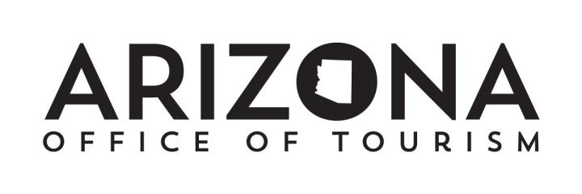

FY21 Prop 302 Timeline

Monday, April 13, 2020
Send Prop 302 Committee guideline revisions, timeline and FY20 carryover document for approval.

Friday, April 17, 2020
Letters/emails to DMOs requesting the FY21 intent to participate document w/ new guidelines attached and FY21 Prop 302 Guidelines posted on AOT’s website.

Monday, April 20, 2020
Conference call with DMOs to review timeline changes and carryover plan.

Friday, April 24, 2020
DMOs FY21 intent to participate document due digitally by 4:00 pm.

Friday, May 8, 2020
AOT will give DMO’s a projected 4th quarter Prop 302 funding amount to complete their carryover doc.

Wednesday, May 13th, 2020
DMOs notify AOT of any unused FY20 funds that they intend to carry over into FY21 and submit their official carryover document.

Friday May 15, 2020
AOT distributes projected fund amount to DMOs for FY21 plus FY20 carryover.
* Pending Final confirmation from AZSTA from projected allocation

Friday, May 29, 2020
Prop 302 FY21 Applications are due. (no hard copies required this year. A photo or PDF of Appendix A to be submitted with Application digitally). Applications must include FY20 carryover funds.

Friday, June 12, 2020
Prop 302 Committee Meets to review and approve FY21 applications.

Wednesday, June 17, 2020
FY21 Prop 302 Award letters are distributed to DMOs reconfirming their FY20 carryover amount included.

Monday, July 1, 2020
Participating DMOs begin their marketing and promotional activities.

Friday July 24, 2020
FY20 Year-End Expense Report Due.

Friday, January 29, 2021
FY21 Mid-Year Expense Report/Change Log Due in digital format.
.
Friday, July 30, 2021
FY21 Year-End Expense Report Due in digital format.

